Handling an infectious spill
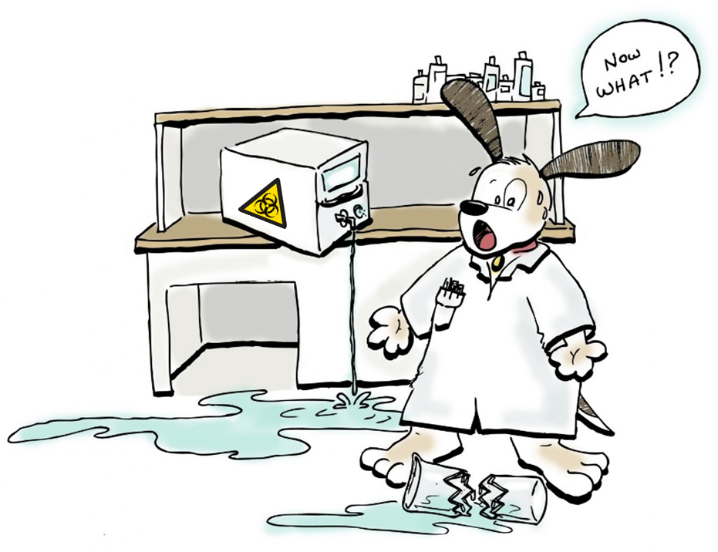
Replace panic-dog with a picture of a lab member wearing Personal Protective Equipment suitable for the risks in your laboratory

- Clear and close-off the area until the aerosols have settled
- If it´s a big spill, do not handle it yourself! Ask for help.
- Risk assess the spill
- Put on Personal Protective Equipment
- Cover the spill with absorbent, start from the outside and work inwards
- Pour on disinfectant without splashing, start from the outside and work inwards
- Give the disinfectant time to inactivate the infectious substance
- Seek out and decontaminate any splashes
- Clean up, start from the outside and work inwards
- Repeat if necessary
- Remove Personal Protective Equipment
- Wash your hands properly
- Open access to the area again
- Write down the incident report while it is all fresh in your memory
- Refill the spill-kit

